Piotr Królak

Homework 1 Quantitative Macroeconomics

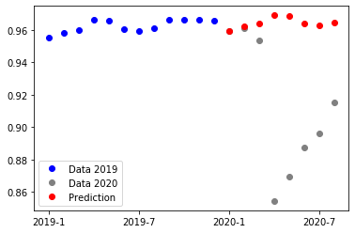**Question 1:**

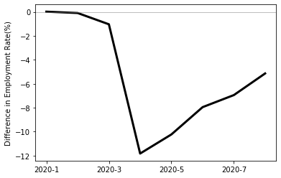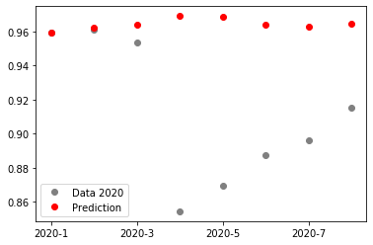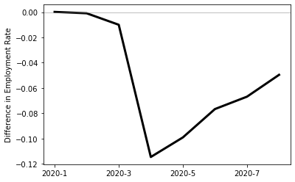Let us start with plotting employment rate for the U.S. and discussing results. The prediction for time series were obtained using SARIMA (0,1,0)(1,0,0,12) model that yields decent AIC and has statistically significant parameters, that model will be used in further predictions in the homework unless it is stated otherwise. In the data we can notice a small deviation from prediction in march, followed a massive decline in April, when the rate was almost 12 % lower than prediction. Then it steadily recovers, reaching value of about 5 % below the trend in August. Generally, the shock in economy is enormous and the recovery process lasts and will last some time.

**a) Education Groups:**

Now let us analyse employment among four education groups:

* < HS – people that have not finished High School education,
* HS – people with High School diploma
* College – people with finished College
* 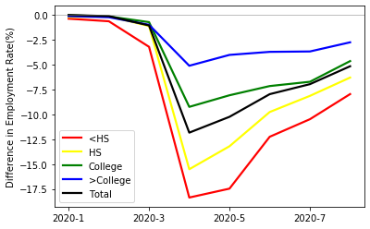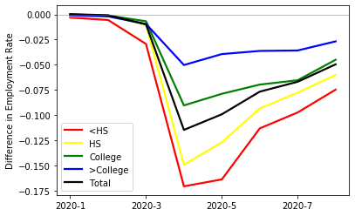>College – people with Master’s, Professional School or Doctorate Degree

Who is hit the most by the pandemics? People with lower education were more frequent to loose the job then those with higher. The employment rate in April for people without finished College were almost 17.5 percent points lower from the prediction, while for those best-educated It was about 5 percent points. It could be explained by the fact that people with lower education cannot are often required to perform tasks which disable possibility of teleworking. We can also notice that the lower the education the fastest recovery.

**b) Industry:**

Now let us described employment rate by industries. From the list of industries a two groups were form. One that embraces lower half of the industries measured by the ability to telework – Physical. The second with the upper half – Dematerialized. Teleworking ability was gathered from IPUMS ATUS WRKHOMEABLE variable with data from 2018.

|  |  |
| --- | --- |
| **Physical** | **Dematerialized** |
| Foundries | Business, technical, and trade schools and training |
| Ordnance | Barber shops |
| Coating, engraving, heat treating and allied activities | Farm supplies, merchant wholesalers |
| Commercial, industrial, and other intangible assets rental and leasing | Alcoholic beverages, merchant wholesalers |

Table 1 Examples of Physical and Dematerialized industries

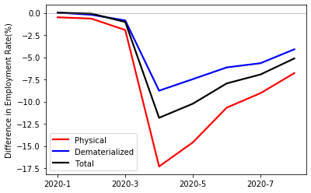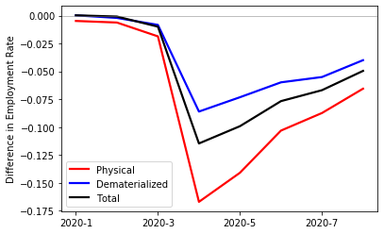We may observe that Physical industries were struck much stronger than Dematerialized, with values of employment rate corresponding to those for people without College. It may be explained same as previously, industries with low ability, possibility of teleworking lose more, because due to confinement people were unable to perform their tasks. It is also observable faster recovery of Physical industries and that values for August are much below prediction.

**c) Occupation:**

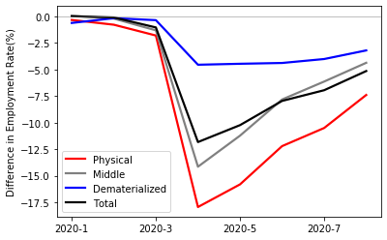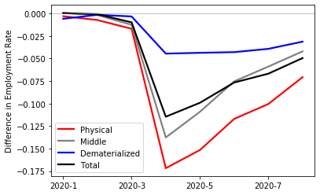Occupation was divided using identical approach as industries, but into three groups (Physical, Middle, Dematerialized).

Here the conclusions are similar as previously. Not the Physical occupations but also Middle were strongly hit by the shock. The employment was 10 % lower for more than 70 % of occupied people. Also after decline in April the employment were almost constant since then and still much below trend.

**Question 2:**

Now, let us examine average working hours.

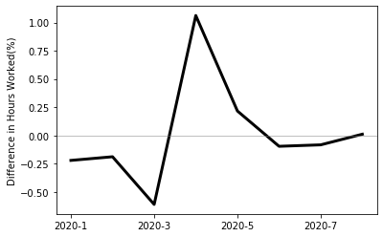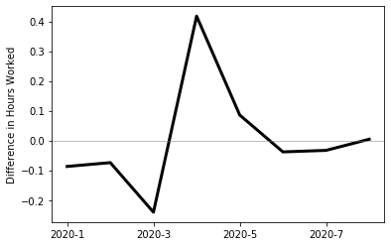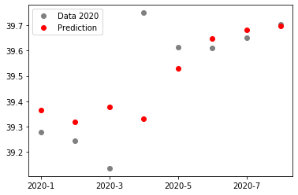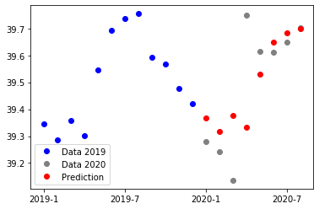This year started with average hours worked slightly below prediction, then there is a drop in March followed by something that at the first glance may look surprising, an sharp increase. After which the values converge to the trend. One reasonable explanation for this is that in April, when many employees were made reluctant, other that remained occupied worked more or were forced to work more for some period. Maybe there is an another explanation. People that started to telework were spending more time at work, because they were less efficient. Then, they either came back to usual work or learned how to telework and this deviation diminishes. We can notice that the deviations from prediction are much lower for average hours worked then for employment rate.

**a) Education Groups:**

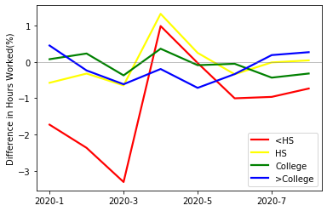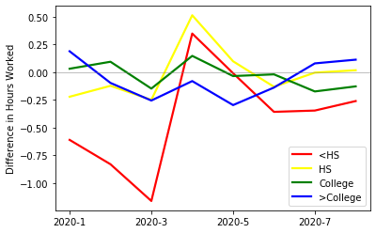The people without High School were affected by the decline in March, but then this group and High Scholl_educated benefited from increase in April. Here I would argue that it is plausible that after firing (too) many people the remainder employees had to work more to perform tasks in April. When it comes to people with better education, the deviations from prediction are small.

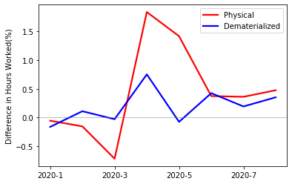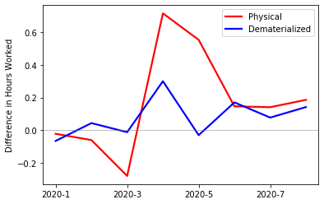**b) Industry:**

Speaking of industries we can observe similar pattern: decline in Physical ones in March and then sharp increase in April, where Dematerialized industries fluctuate slightly with a visible peak in April.

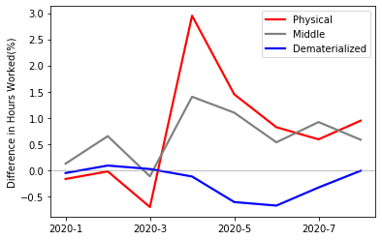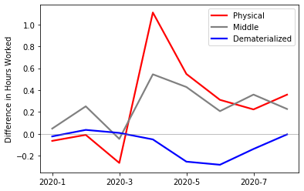**c) Occupation:**

Occupations reveal similar properties like industry. One new finding is when introducing the Middle group, which behaves similarly as Physical the Dematerialized occupations are constant over time.

To sum up, in terms of average hours worked arrival of Coronavirus did not bring such huge deviations from predictions. Mostly affected were people with worse education and lower ability to teleworking, which after a slight decline in March were induced to work more in April.

**Question 3:**

Here let us bother with aggregated hours, let us denote it by H, which is a product of h (average hours) and N (number of employees).

$$H=h*N, we take logs$$

$$\ln{H}=\ln{h}+\ln{N}, then derivative$$

$$\frac{∆H}{H}=\frac{∆h}{h}+\frac{∆N}{N}$$

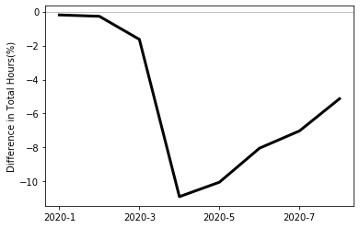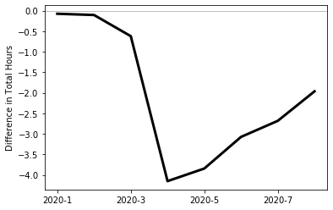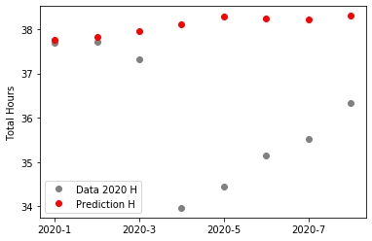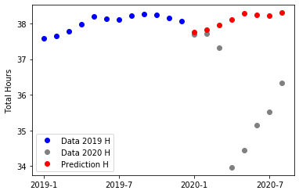Where the first, second and third term are already calculated deviations from the prediction as a percentage.

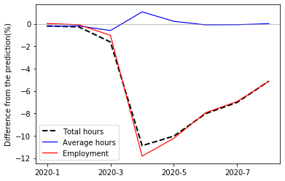In the data we can notice similar pattern to the behaviour of the employment rate, slight decline in March, huge drop in April and slow recovery in periods after. In August the total hours were still 5 % below the prediction. We may notice the amplitude of the shock is a bit smaller than for employment rate.

So to analyse decomposition of total hours I will look at the graph representing the deviations from predictions for total hours, average hours and employment rate. With no doubts it is employment rate that affects the total hours most, the lines representing them are almost overlapping. It is worth noticing that the huge decline of employment rate in April had some countereffect with an increase of average hours in April.

**Question 4:**

Here let us describe behaviour of earnings during the crisis, being more precise the behaviour of Week Earnings (variable EARNWEEK from CPS). Here the model for predictions was changed to SARIMA (1,1,0),(0,1,0,12).

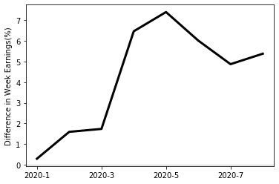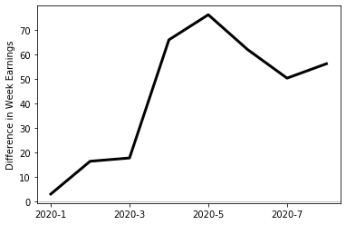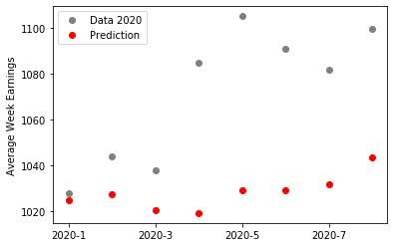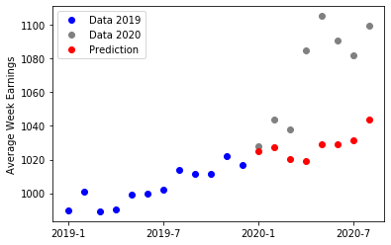Not only have the earnings increased due to trend but also there were other factors that pushed earnings well upon the prediction. The 2020 started well with earnings upon the prediction, even before Coronavirus arrived, but then in April started a huge surge (up to 7 %) that did not diminish, yet the values in August are still far upon the predictions. What may be one of the possible explanations is that in April the average weekly hours increased, so of people’s earnings depend on how much they work the earnings should also grow, but the increase in working hours were much smaller (up to 1%).

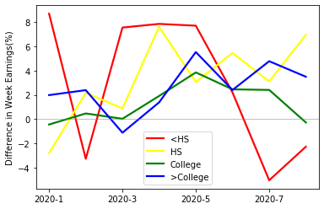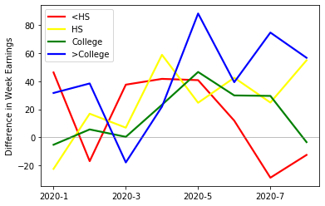**a) Education Groups:**

It is tough to notice any clear pattern. It could be argued that during the hardest confinement (March-April) it was the poor-educated who benefited but then it changed slightly in last few months.

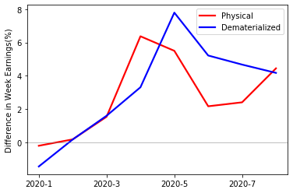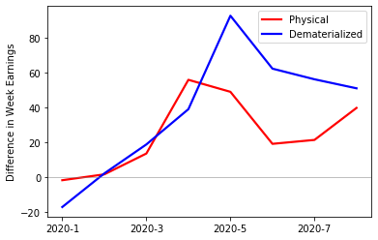**b) Industry:**

Speaking of industry groups it seems that both group represent similar pattern and had their earnings increased since March and the earnings of employees in dematerialized industry were higher following from May up to now, but it seems to be converging.

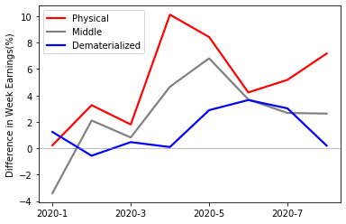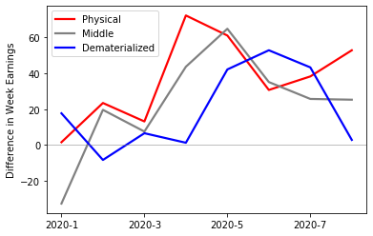**c) Occupation:**

Regarding the occupation groups the situation seems to be unclear, all three groups earned more than predicted and probably it was the Physical group which benefited most.

**Question 5:**

Speaking of Poland official data are collected and published by institution called GUS (National Bureau of Statistic). Accessing this site: <https://stat.gov.pl/en/> gives access to the data. Statistics regarding unemployment rate and average wages are widely available and I am going to focus on it. They are prepared on a monthly basis and does not present data divided into different industry, occupation or education groups, only aggregated values.

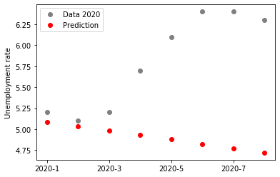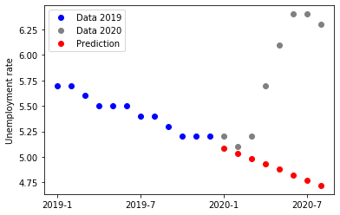Let us begin with unemployment rate. The data is seasonally adjusted, so I will use an ARIMA (0,1,1) model to make a prediction. Before describing results I would like to stress out that according to the methodology and formal definitions to obtain a status of unemployed person in Poland to person cannot work (that is kind of obvious) but also must be willing to work start full-time work and be registered in Labour Agency. So the data are usually underestimated, especially when the lockdown was introduced in Poland, many people do not registered (about three times less than usual[1]), due to limited capacity of Labour Agencies or fear of being infected.

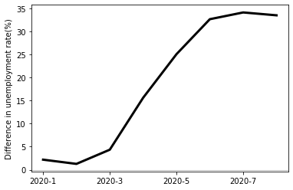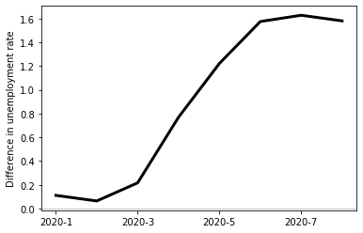

Also Polish labour market was hit by crisis induced by coronavirus, we can notice that unemployment sharply rose above the 6 % according to the official data. On the one hand that is maximally only 1.6 percent points above the prediction (comparing to 12 in the US), but on the other hand the relative increase is really big – up to 35 %. What is striking, comparing to the US, that the unemployment rate grew steadily from March to May since when it starts to recover a bit, there was not a one big strike.

Data concerning wages, being more precise Average monthly gross wages and salaries in enterprise sector is presented below:

1. There exist a current research or scientific project on Polish Labour Market that tries to provide better data and analysis based on survey and can be found here: <https://diagnoza.plus/> but there is no any English version